M 063 Crossing Wing Play and Goalkeeper dealing with

Requirements: Half a pitch all players with a goalkeeper several soccer balls (large squad preferred).

General Scenario: Goalkeeper to control defenders for all crosses, positional play and calling

Set up the grid to suit the players available. In our first diagram we have two teams, three strikers and four defenders in the penalty area (one a goalkeeper); Players deliver a simple cross for strikers to attack or defenders to clear, pressure is on the strikers in the penalty area to determine how the cross is delivered. Allow strikers to collaborate on moves and call as required.
You can start with one Team (Team 1) and build up from that.

Play commences: In our diagram: When Attacking player (A) (lets call them overlapping fullbacks ) from Team 1 passes the ball to player (B) and receives a return lay off. Overlapping fullback, Player (A) then carries the ball past player (B) and under instructions from the strikers, crosses the ball as directed - high, low, deep, near post, far post etc. Overlapping fullback, Player (A) then joins the ball collectors and a ball collector joins Team 1.

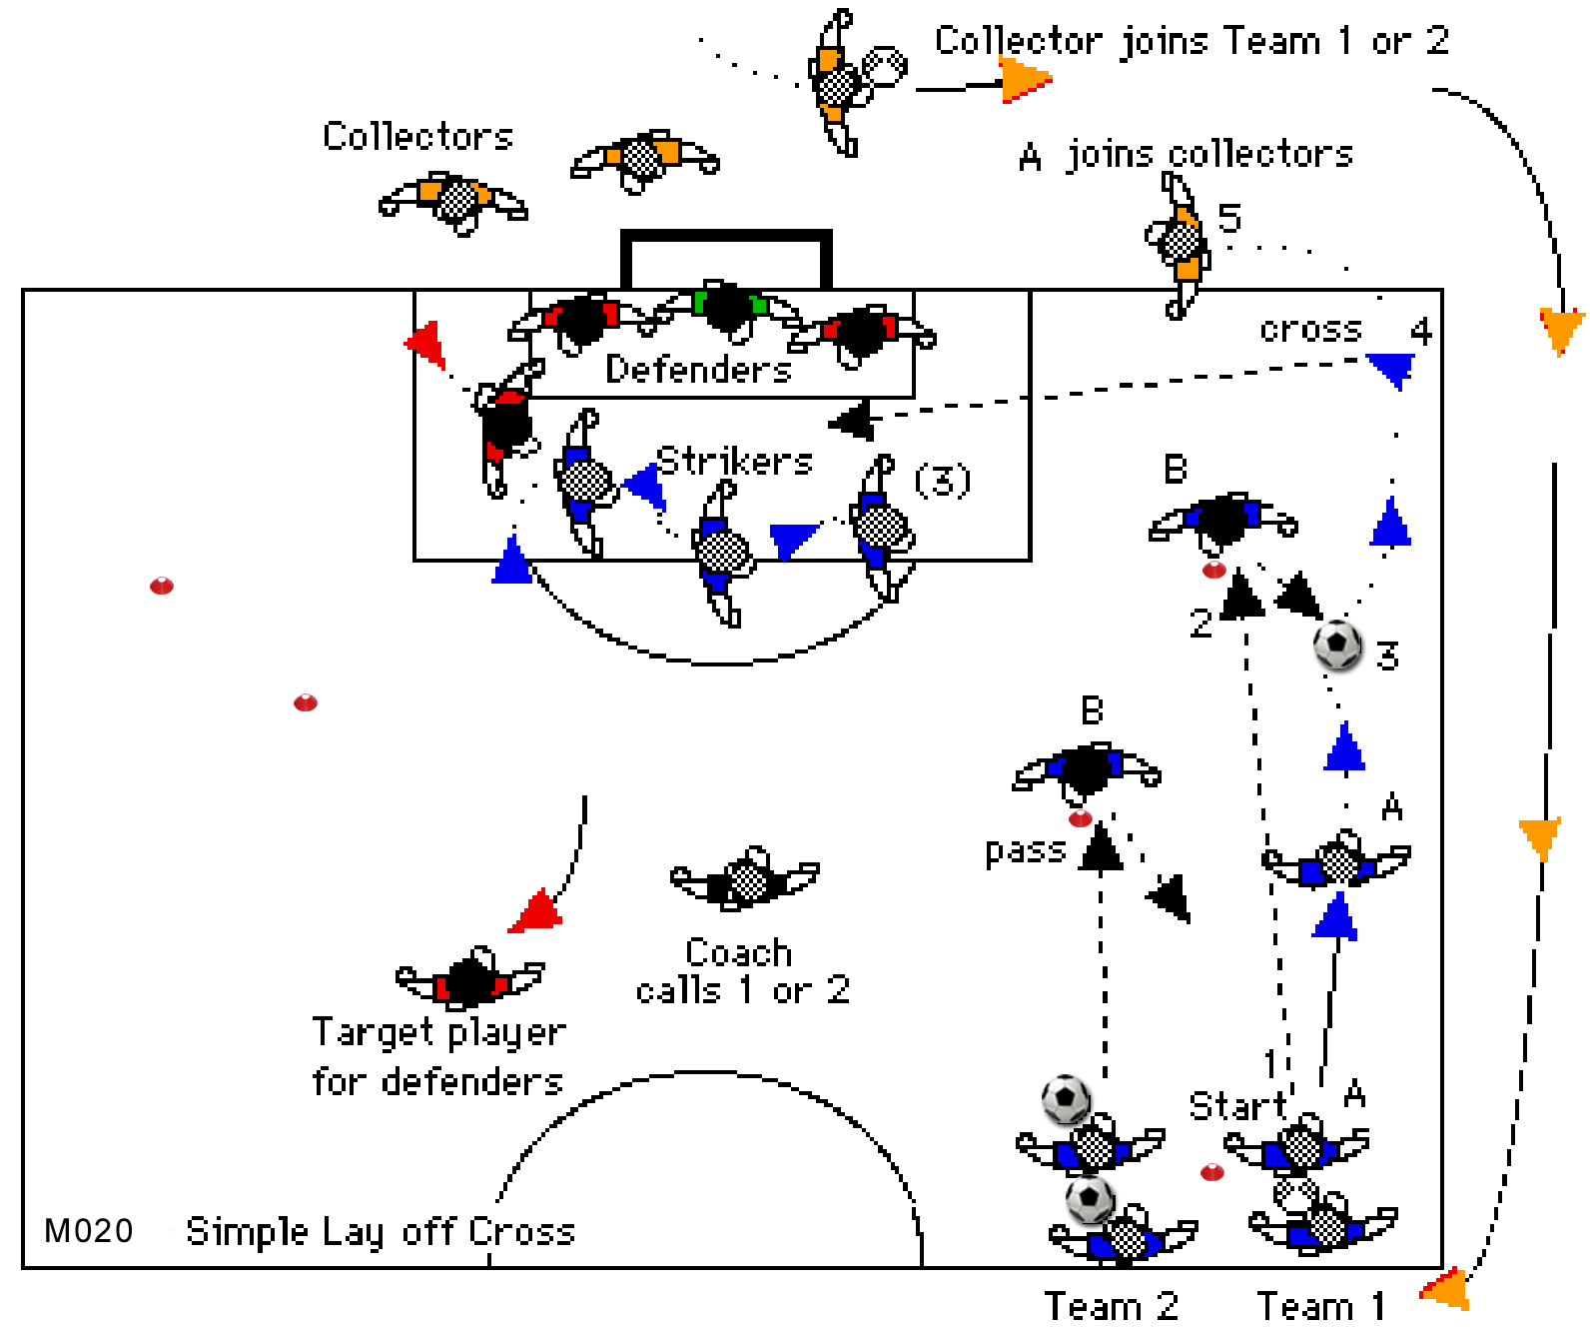
Roles: Defenders To clear the crossed ball, take up defensive roles and score by getting the ball to their defensive midfield player. First importance is to mark up on attackers and clear the ball from danger. - Two touches ONLY allowed. Defenders should work on headed clearances and the goalkeeper makes normal saves

Attacking players To make a prescribed cross into the area of attack as determined by the Strikers. Strikers To formulate the method of the cross, calling for it near post, far post or low high etc. Allow strikers to be innovative and allow them time to discuss their tactics. If you have a large squad you can use two static passers players (B) and two teams (have one team on each side of the park) and you can also change the strikers to give others a go at moving for position when Attacking crosses. Strikers should attack the crossed ball, can go anywhere and have three touches of the ball each. (You set the parameters)

They should work moves such as:-
i. Letting the ball come in low then through a strikers legs or using a dummy to give other strikers a shot on goal.
ii. Near post to flick on off the head to other strikers.
iii. Far post with return cross back across goal.
iv. Changing or switching places.
v. All go far post etc.

Coaching Points Quality of crosses, not just a general cross but because this is not pressured, you need to concentrate on placement of crosses. This is a strikers grid so give your strikers roles such as one deep, one near post, one on the keeper etc. and encourage them to work out moves - the pressure is then on the Overlapping fullback player (A) to deliver the appropriate cross.

Note If using only two lines put the second line deep for a deep in field cross (Number two). Or put one line on the opposite side of the park so that crosses can be from either foot, and defenders and strikers have to deal with crosses from either side.

I usually start this grid on one side only, then bring in all other players and set up lines one either side with Teams 1 and 2 or more. I can then throw crosses into the area from both sides as seen below. If you do not have sufficient players for two, three or four lines use one, one line still works well. But more will add pressure.

M 020 Phase ii
As A Pressure grid
Set up as many lines as you have players. In our example we have four lines, Call one side odd teams 1 and 3 the other even 2 and 4 As play is called strikers must ALL touch the Even or Odd post as called BEFORE playing the ball.

For smaller groups
If you only have a small squad reduce the teams or take out some strikers or remove the central defender and some collectors - let "overlapping fullbacks" players collect their own ball. You can also use just two feed players.

Play begins when: The coach calls a number Put odd numbers on one side, even the other, then it is easier to remember the number 1 or 3 that changes the side of attack.
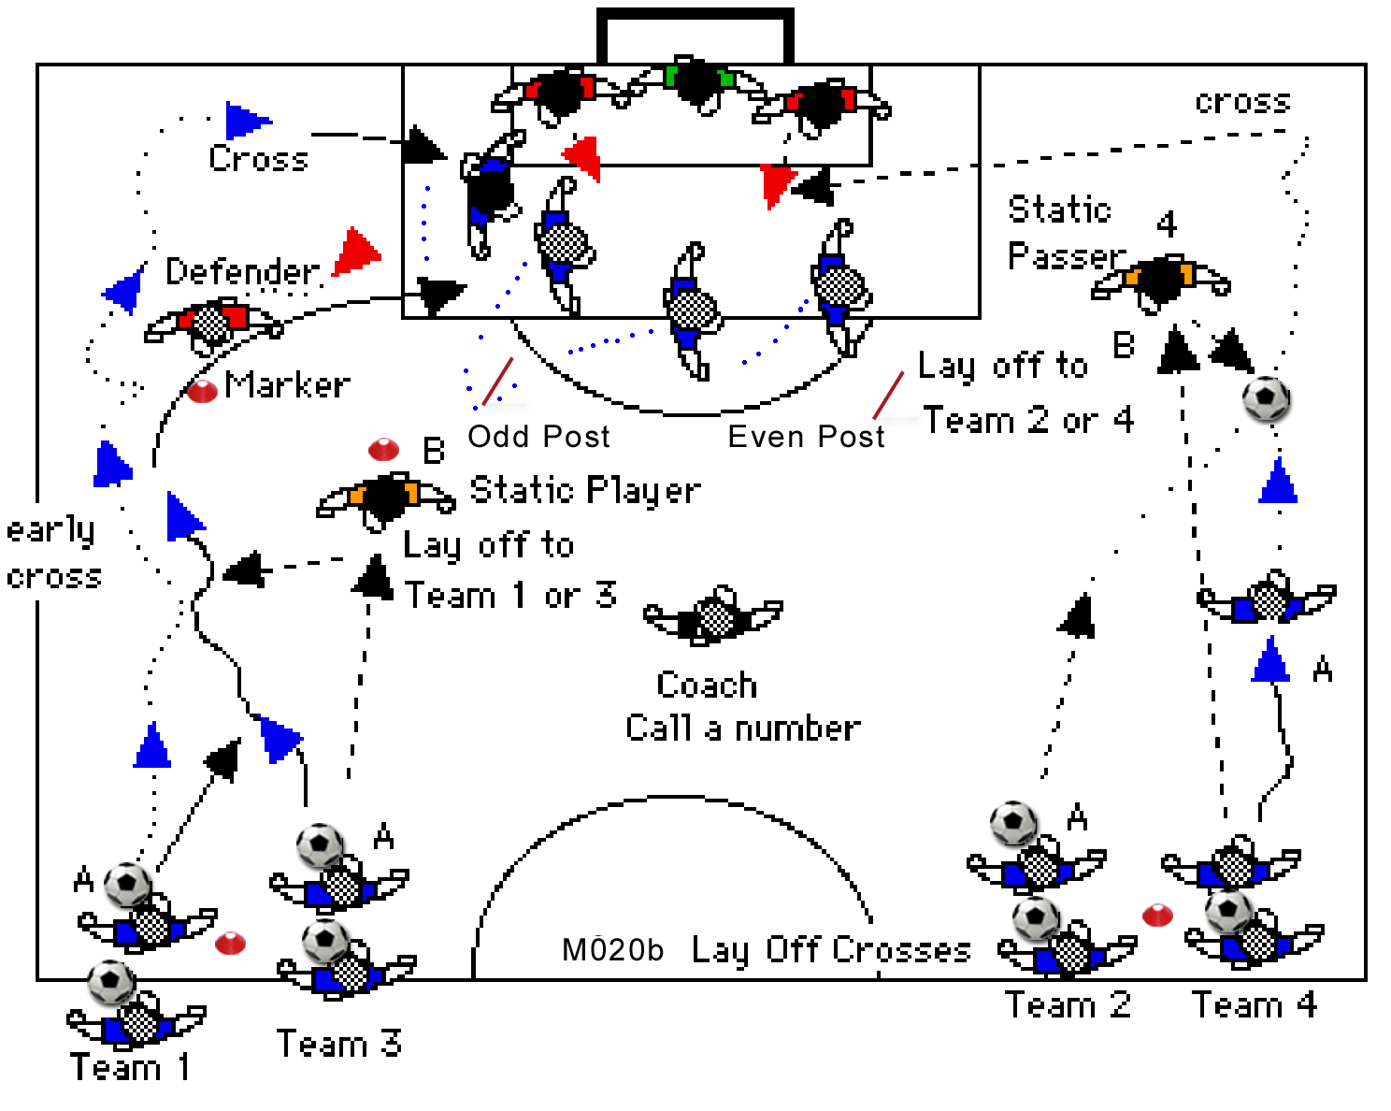
In the first example "number four" has been called and this overlapping fullback player (A) passes the ball to a static team mate player (B) on that side of the park.

All strikers have to run to the even post after the last attack.

Player (B) lays the ball off for the overlapping fullback, player (A) to run on and collect. The overlapping fullback player (A) then carries the ball past player (B) and crosses the ball.

Strikers and defenders take up positions for the cross from that side and call the cross.
Immediately after the shot or tackle, the coach calls another number (odd number to switch play) and that team takes off as above; keep crosses coming thick and fast to make defenders and strikers work to get into position for crosses. Put pressure on by calling as soon as the set is ending (KEEP YOUR STRIKERS RE ORGANISING). In our example Team 4 have crossed the ball and Team 1 or 3 will be called in next.

By this time strikers should have a plan and should STILL call the type of cross.

Developments
i. Allow central strikers to attack the ball but they have only one shot for goal at any one time. However any ball not cleared out of danger then they get another one shot only for any deflected ball that does NOT go out of the penalty area.

ii. Put a fullback or defender on one or each line so that the overlapping fullback, player (A) must beat this "fullback" in a 1 v 1 Note: start passively. The defender has a marker to indicate where the tackles can begin so of course your winger can choose to cross earlier - especially if called early by the strikers. Any tackle and the set ends.

iii. When the overlapping fullback, player (A) passes to the feed player, player (B); that player picks up the ball and takes a throw in down the line for the overlapping fullback (A) to run on to and cross.

iv. When the overlapping fullback, player (A) passes to the feed player, player (B); that player picks up the ball and lobs a high ball for the overlapping fullback (A) to run on to and cross.

v. Put a defender on a marker near the middle of the grid to add pressure.


